Build a Docker Jenkins Pipeline to Implement CI/CD Workflow.

Description
Demonstrate the continuous integration and delivery by building a Docker Jenkins Pipeline.
Problem Statement Scenario:
You are a DevOps consultant at Achi Star Technologies. The company decided to implement DevOps to develop and deliver their products. Since it is an Agile organization, it follows Scrum methodology to develop the projects incrementally. You are working with multiple DevOps Engineers to build a Docker Jenkins Pipeline. During the sprint planning, you agreed to take the lead on this project and plan on the requirements, and system configurations, and track the efficiency. The tasks you are responsible for:
- Availability of the application and its versions in GitHub
  - Track their versions every time a code is committed to the repository
- Create a Docker Jenkins Pipeline that will create a Docker image from the Docker file and host it on Docker Hub
- It should also pull the Docker image and run it as a Docker container
- Build the Docker Jenkins Pipeline to demonstrate the continuous integration and continuous delivery workflow
The company's goal is to deliver the product frequently to production with high-end quality.
You must use the following tools:
- Docker: To build the application from a Docker file and push it to Docker Hub
- Docker Hub: To store the Docker image
- GitHub: To store the application code and track its revisions
- Git: To connect and push files from the local system to GitHub
- Linux (Ubuntu): As a base operating system to start and execute the project
- Jenkins: To automate the deployment process during continuous integration
The following requirements should be met:
- Document the step-by-step process from the initial installation to the final stage
- Track the versions of the code in the GitHub repository
- Availability of the application in the Docker Hub
- Track the build status of Jenkins for every increment of the project

Step 1 Open the AWS DevOps lab

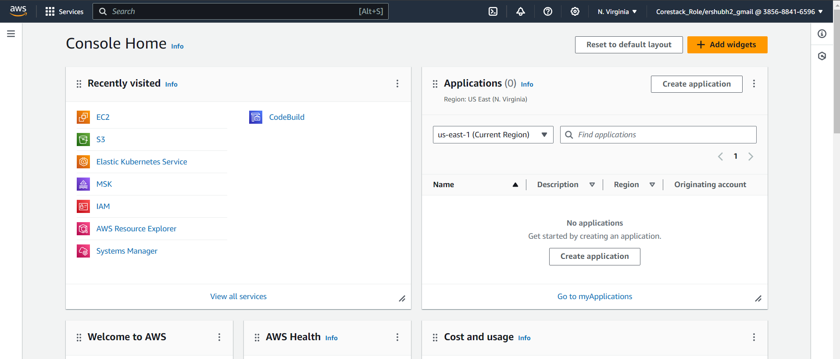

Step 2- create the VPC and provide the basic information.
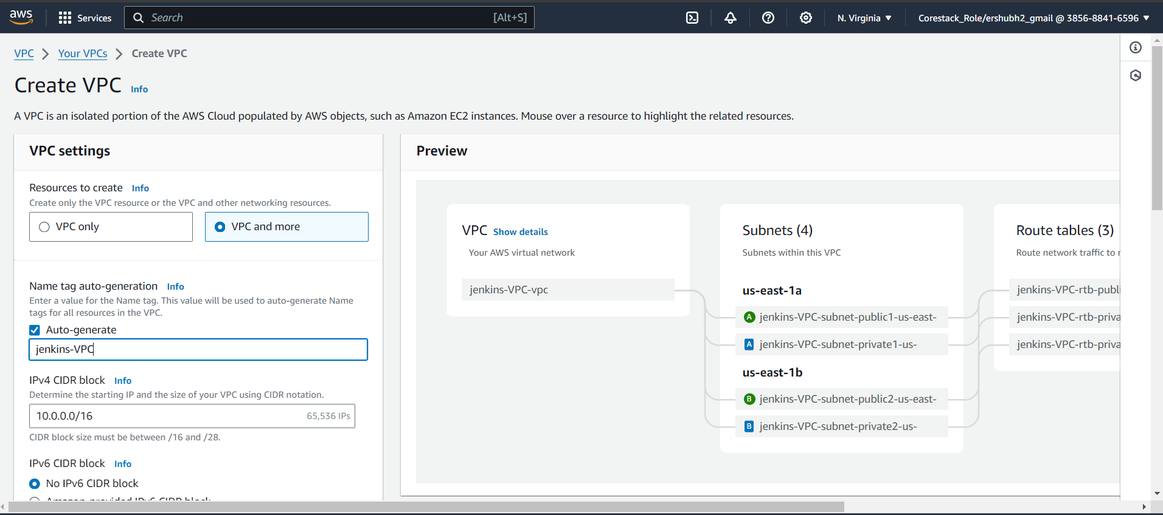

Step 2.1- VPC is created.

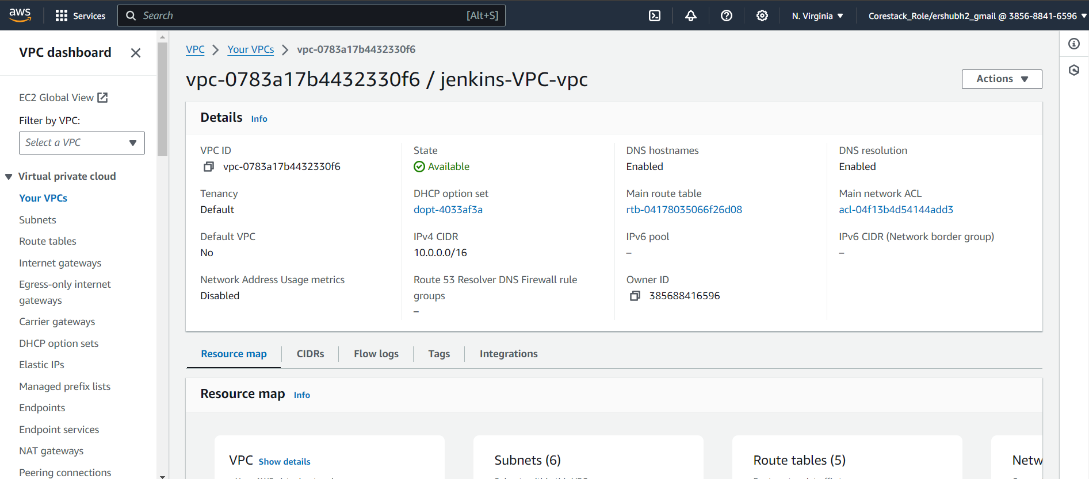

Step 3- Go to the search menu and find EC2 then click the EC2 and create.

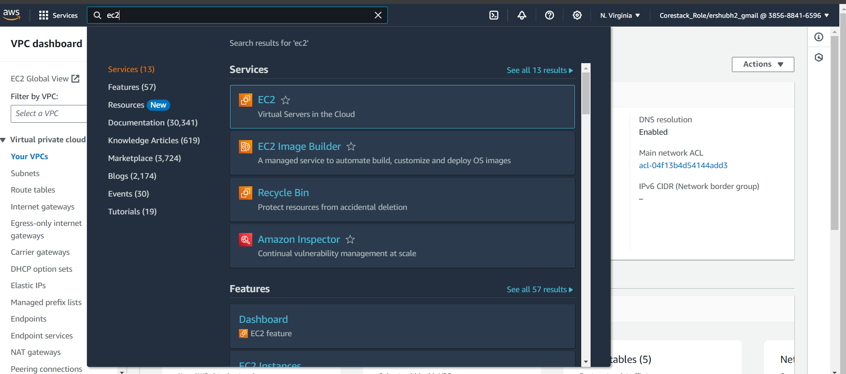

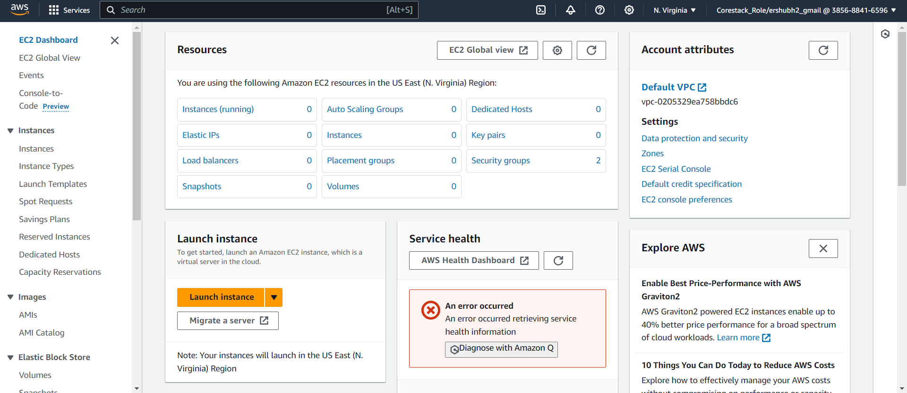
Step 2.1 create the key pairs

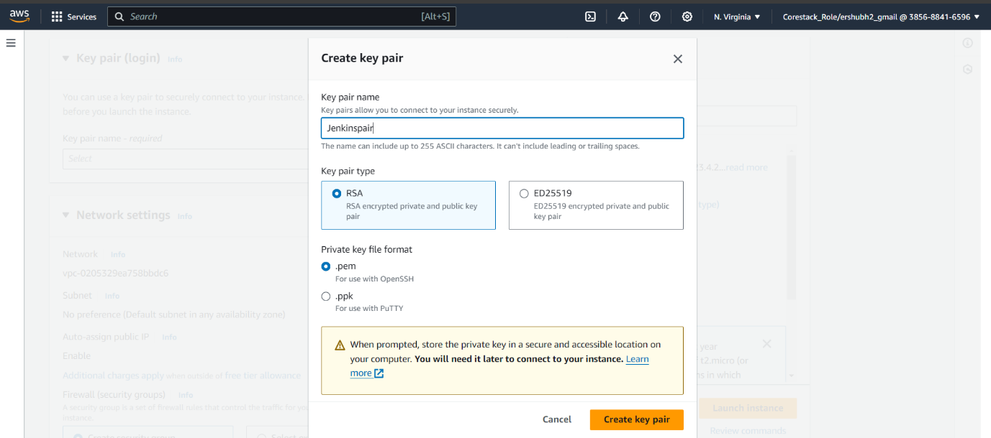
Step 2.2 select the OS images

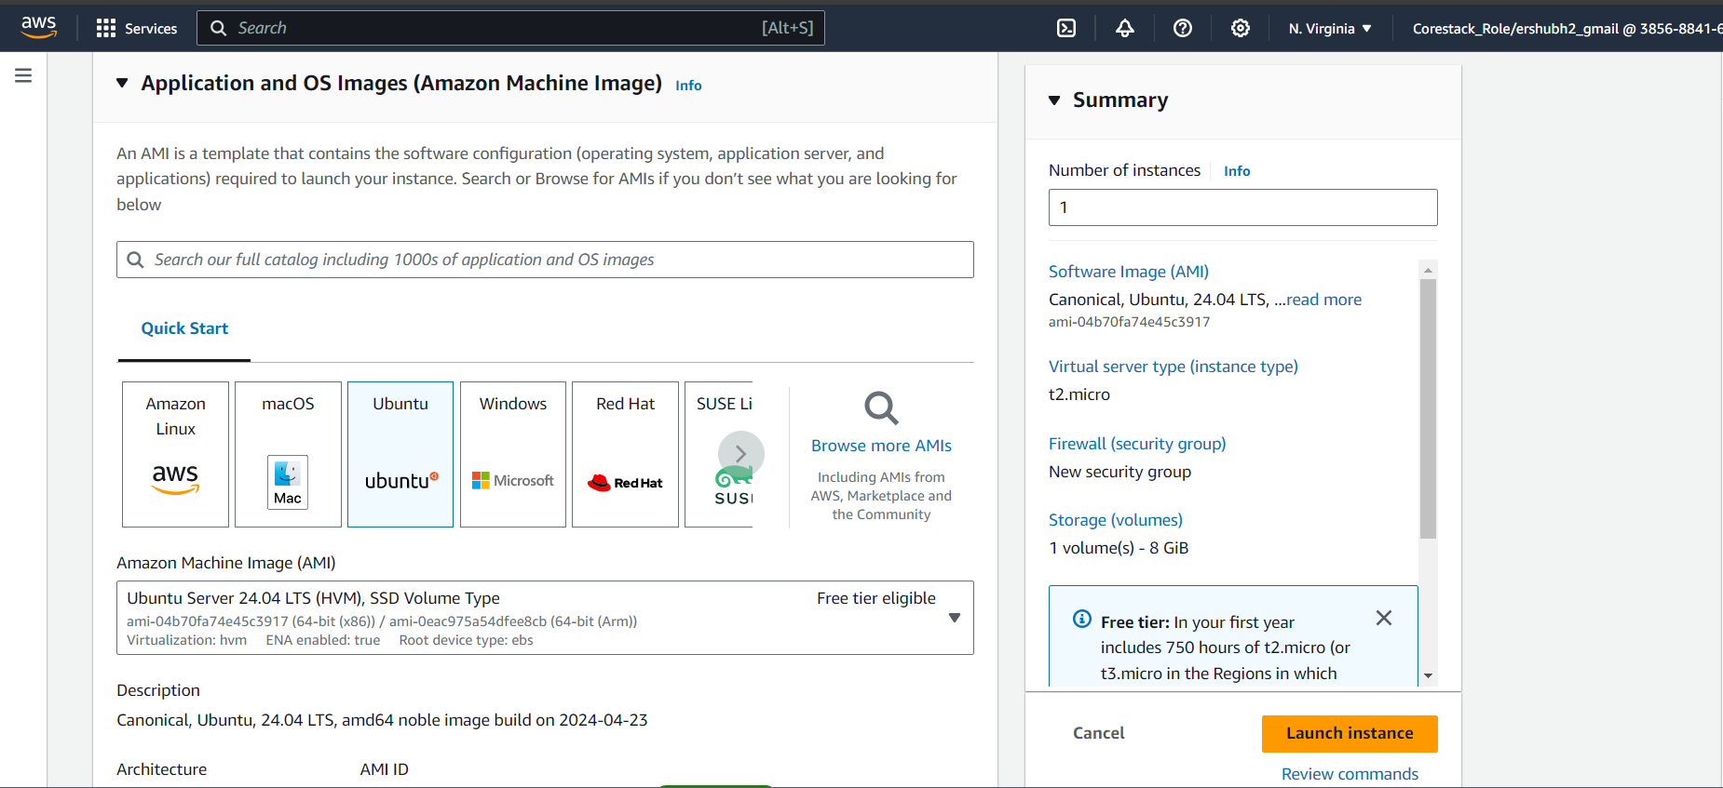

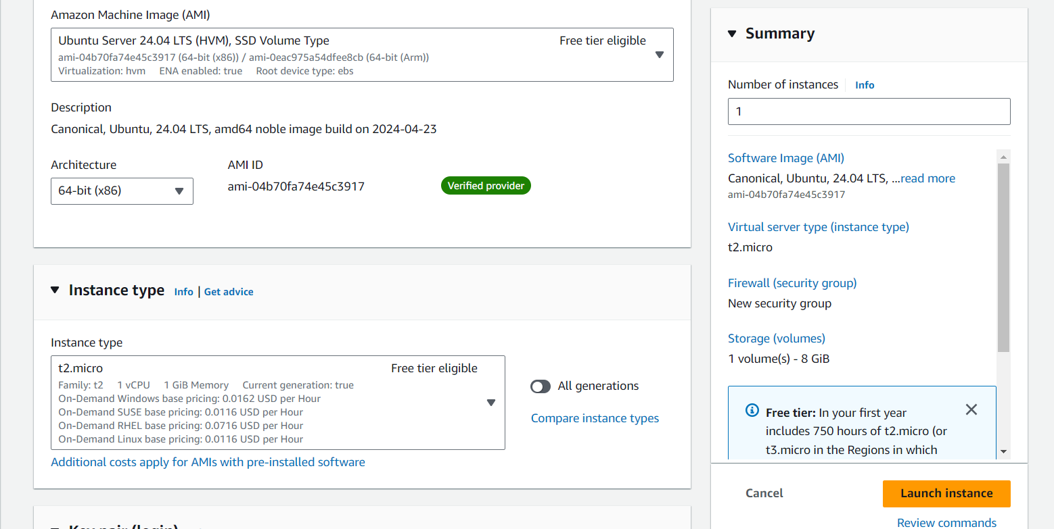

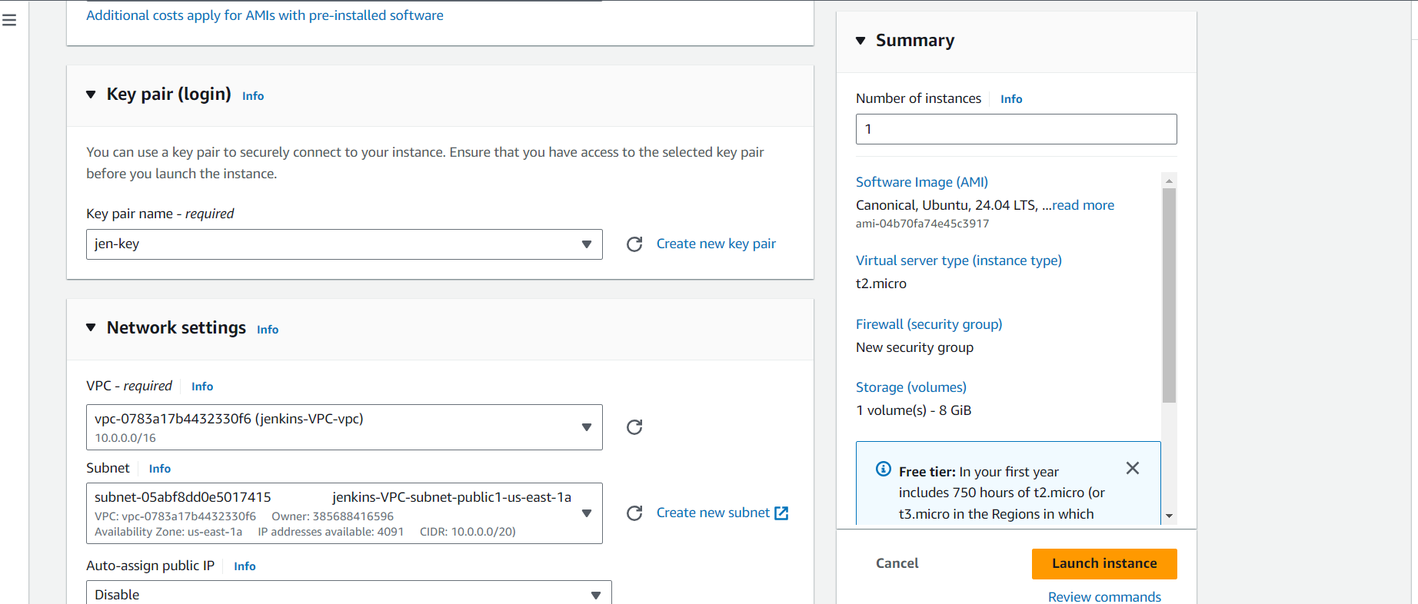

Step 2.3- select the VPC and subnet
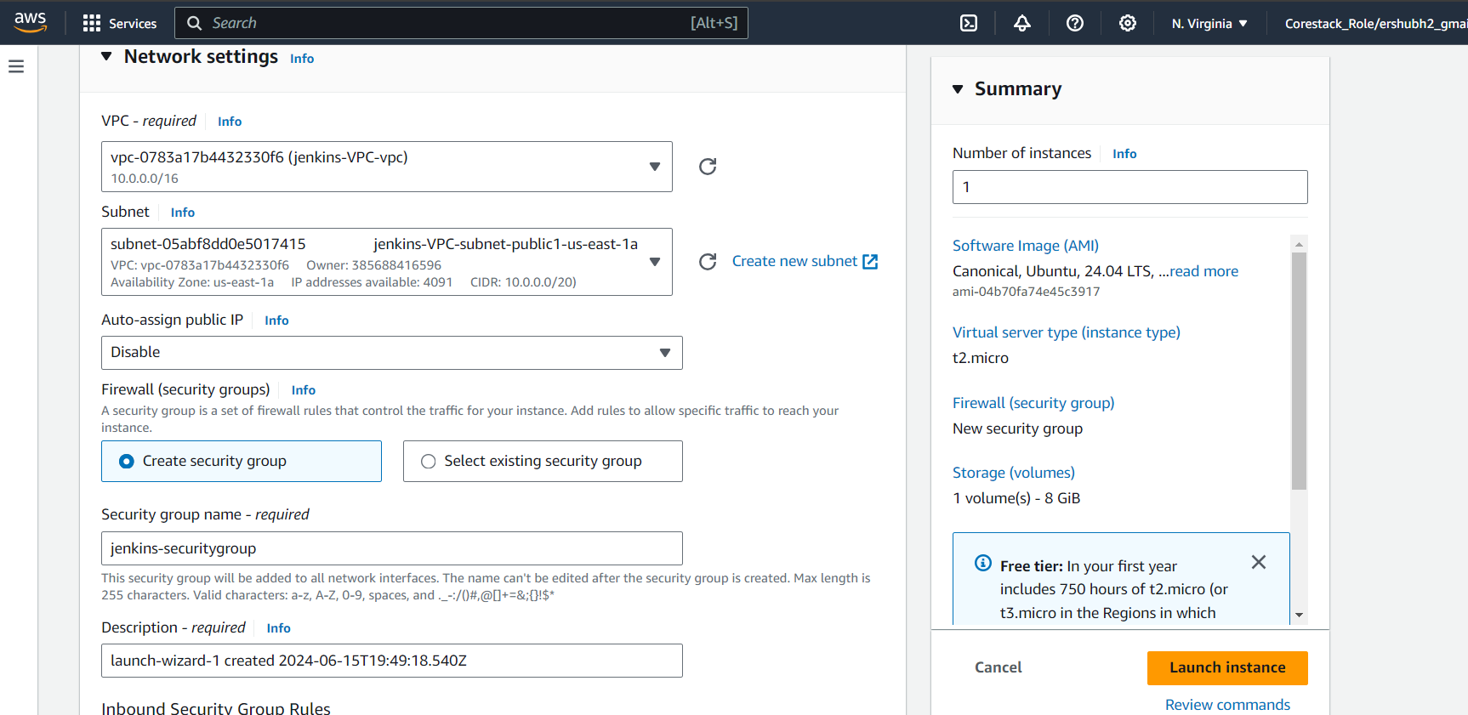

Step 2.4- select the inbound security group rules
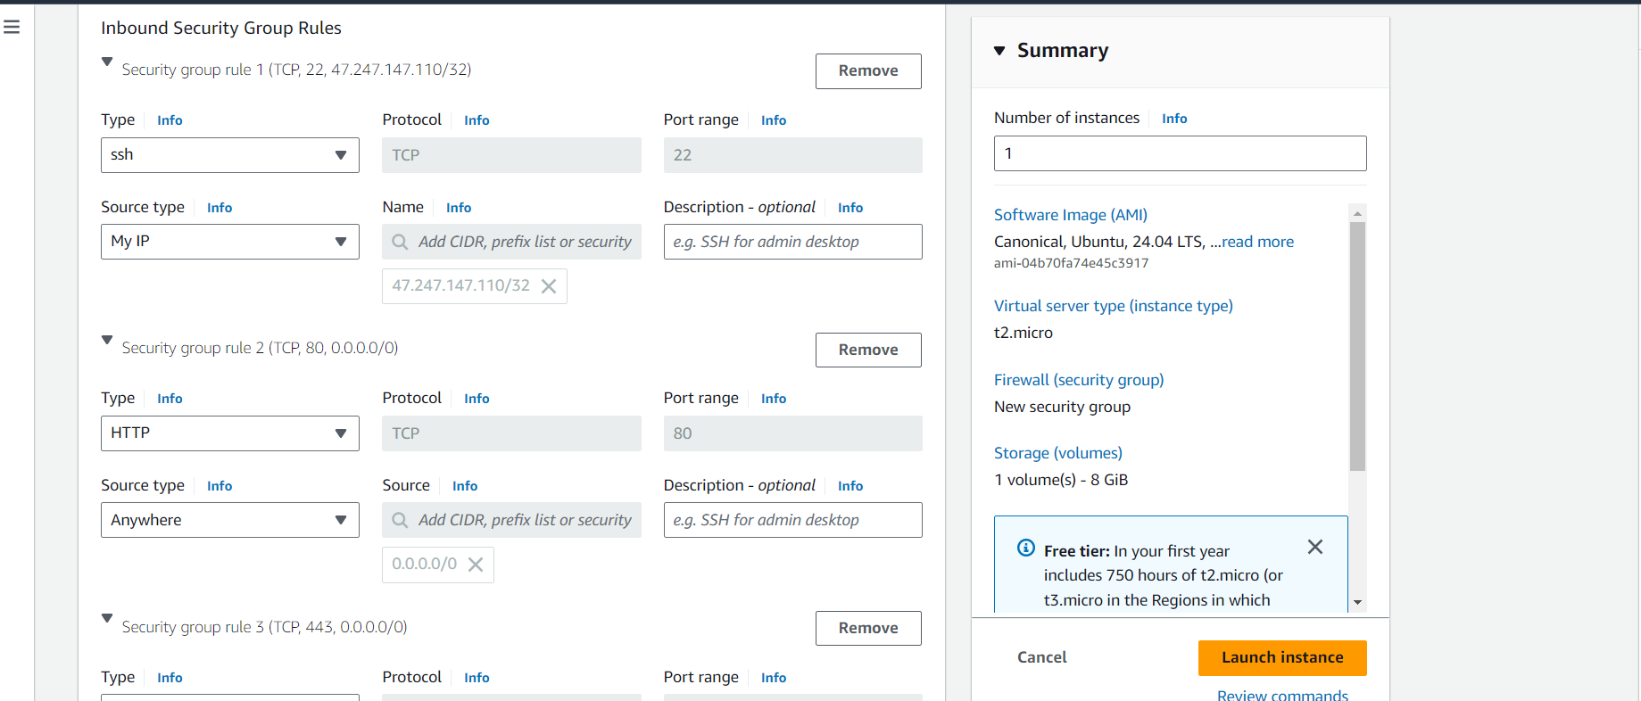

Step 2.5- Click the Lunch instances and create the EC2 instances.

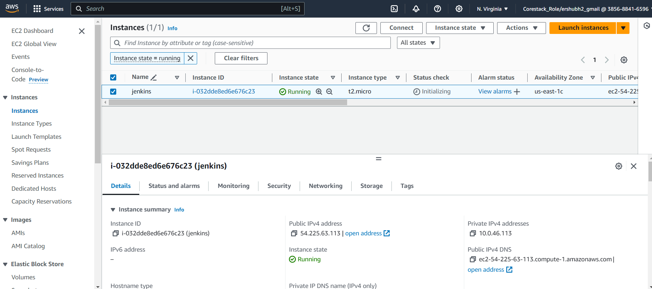

Step 3- Jenkins is running successfully I Putty.

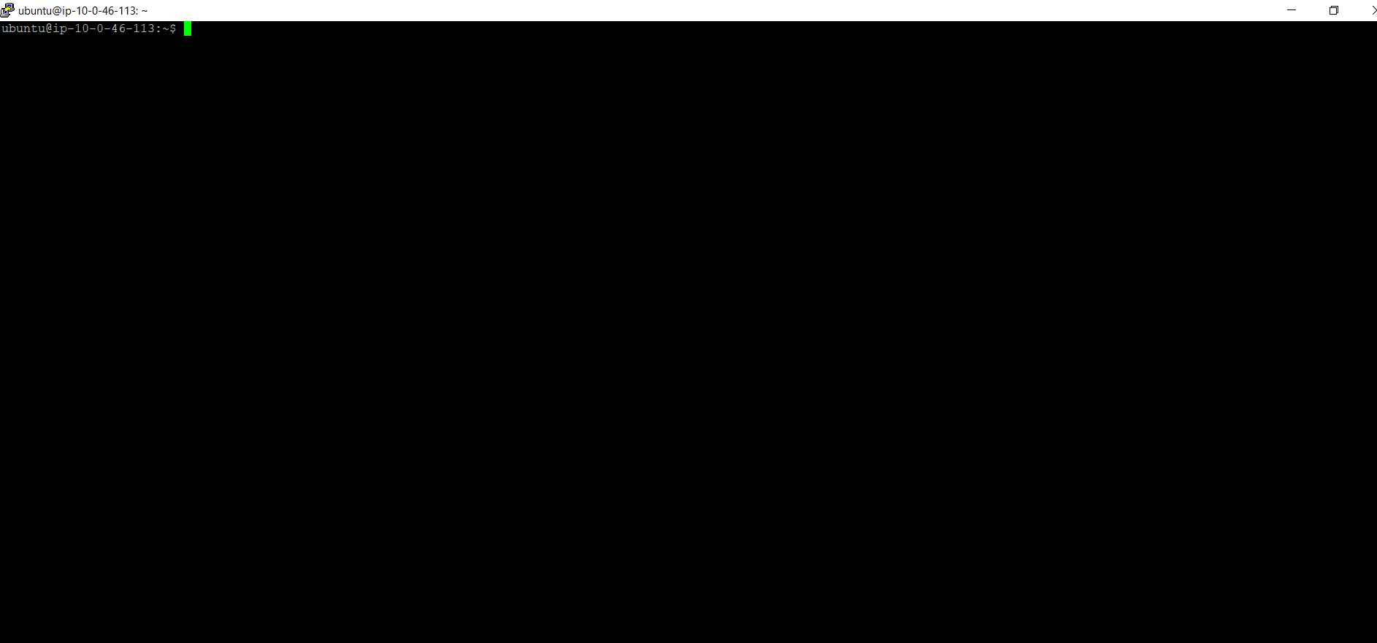

Step 3.1- Jenkins installation follows the command
Jenkins Installation:

- sudo apt update -y
- sudo apt install openjdk-17-jre-headless
- java -version
- wget -q -O - https://pkg.jenkins.io/debian-stable/jenkins.io.key |sudo gpg --dearmor -o /usr/share/keyrings/jenkins.gpg
- sudo sh -c 'echo deb [signed-by=/usr/share/keyrings/jenkins.gpg] http://pkg.jenkins.io/debian-stable binary/ > /etc/apt/sources.list.d/jenkins.list'
- sudo apt update -y
- sudo apt-get install jenkins
- sudo systemctl status jenkins
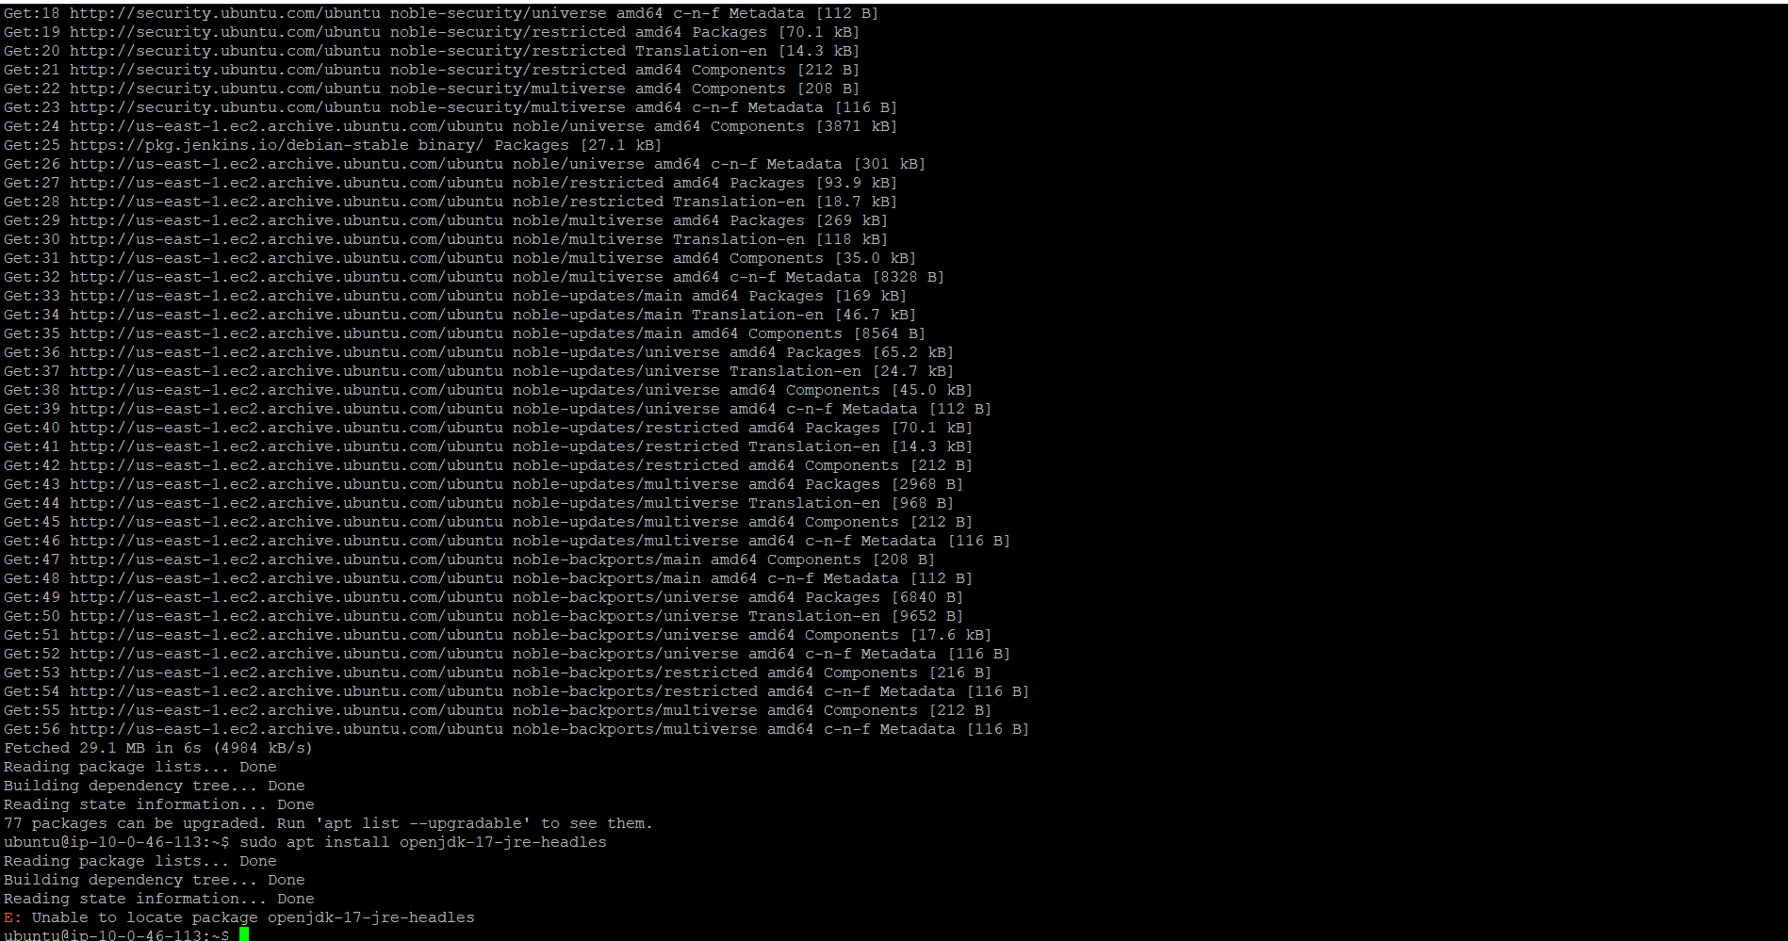

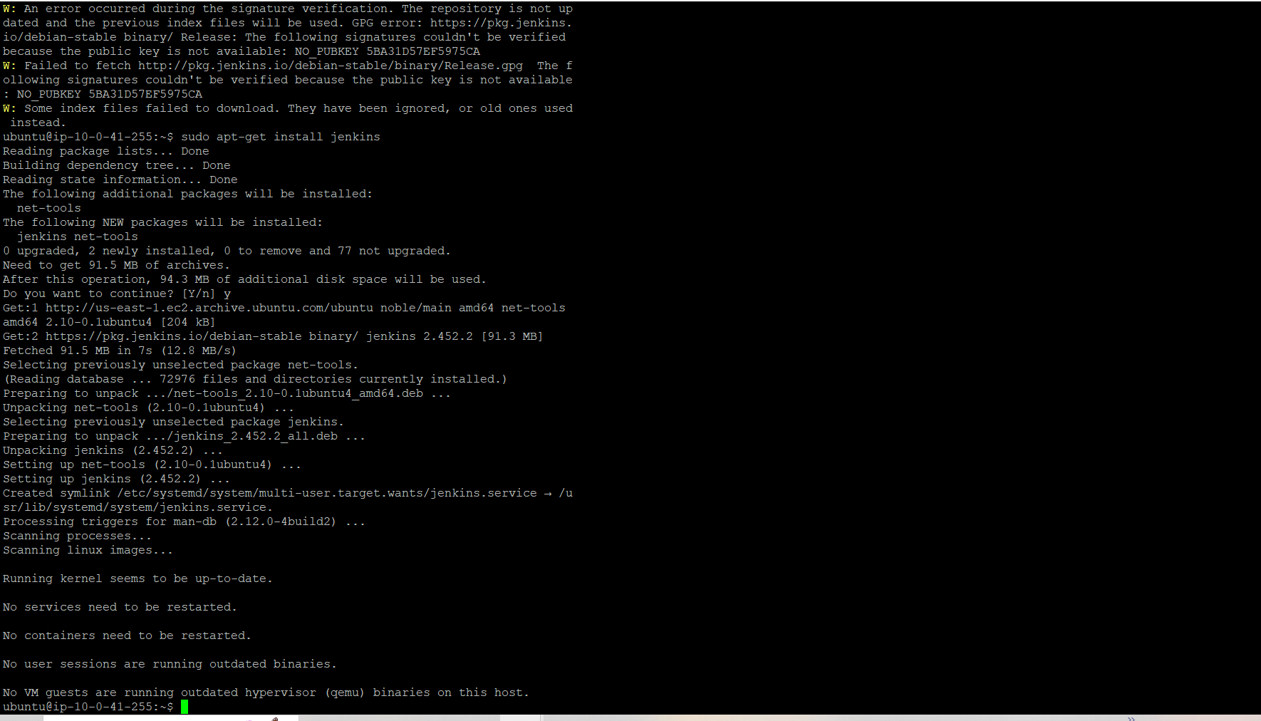

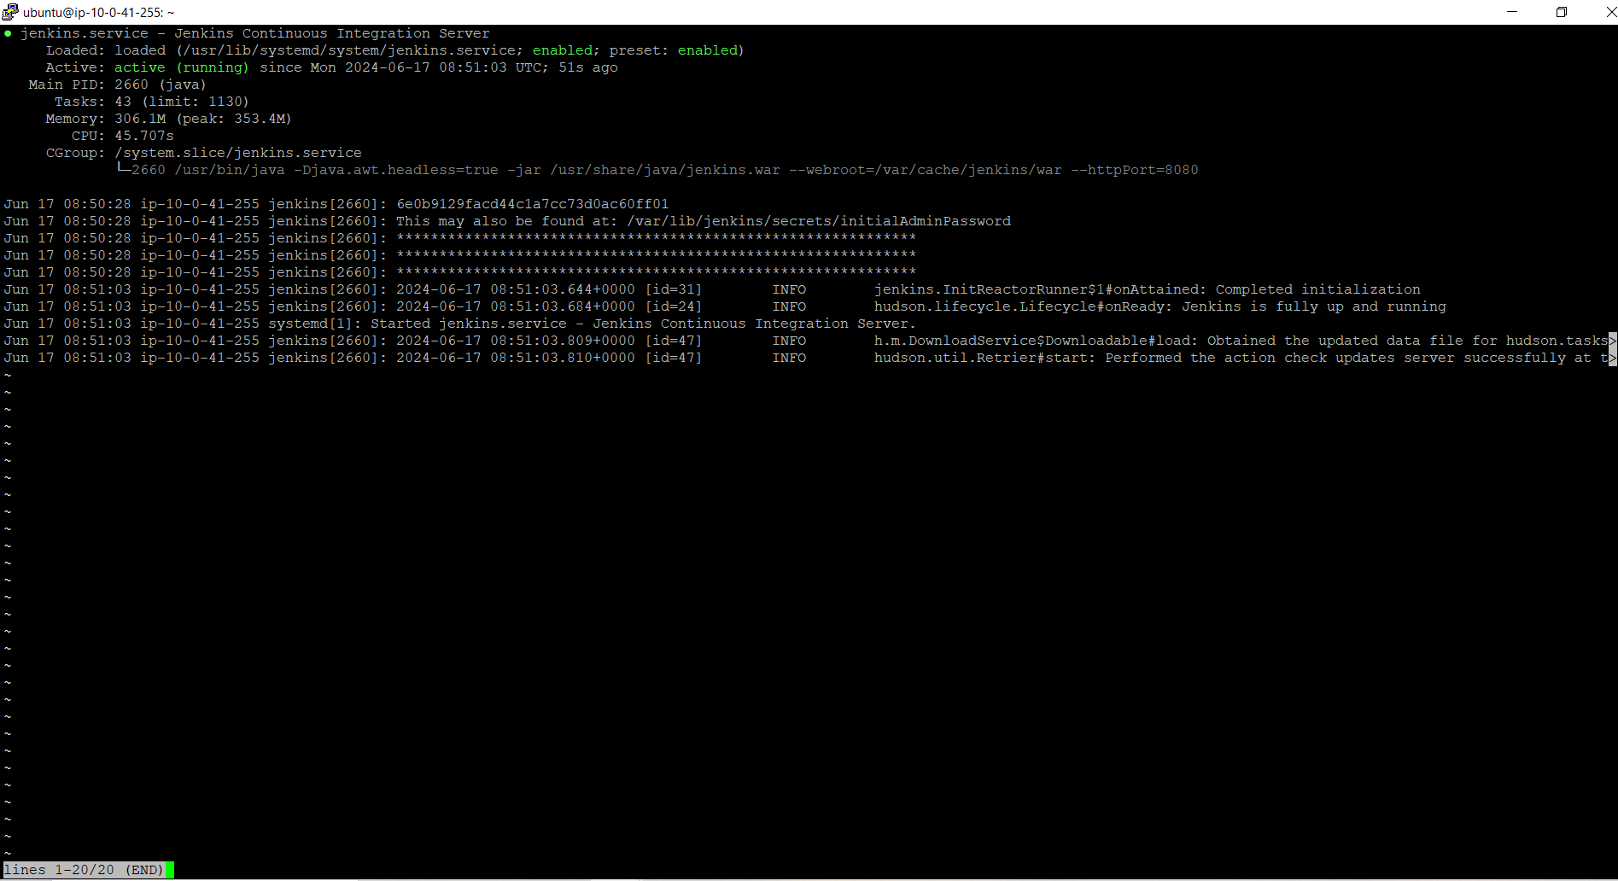
Step 3.2- Open a browser on a URL http://localhost:8080 and on field Administrator password, paste the
copied value.

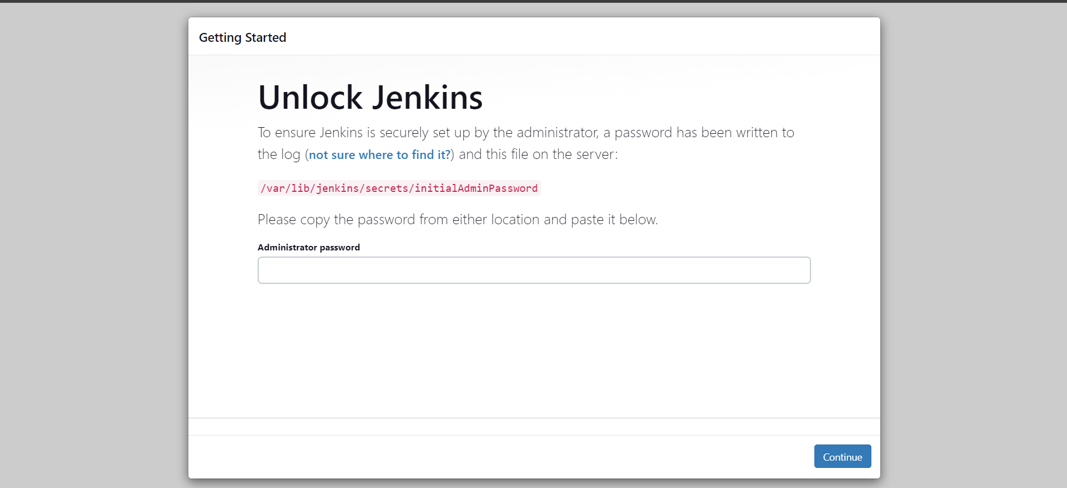

Step 2.3- Click on Install suggested plugins

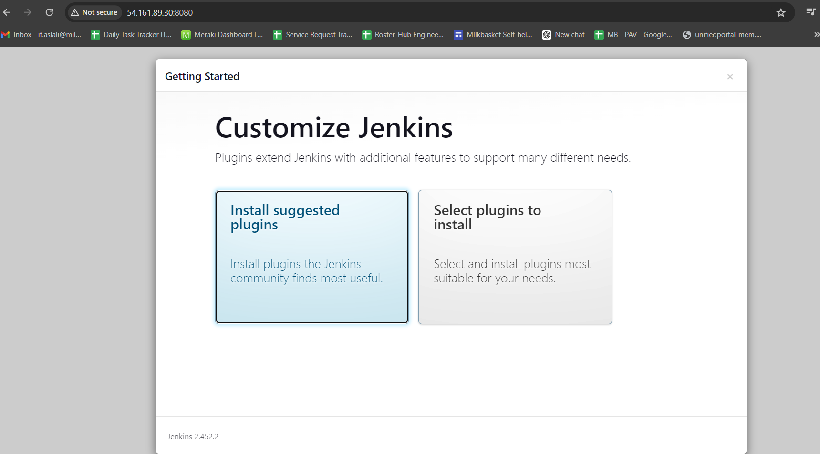

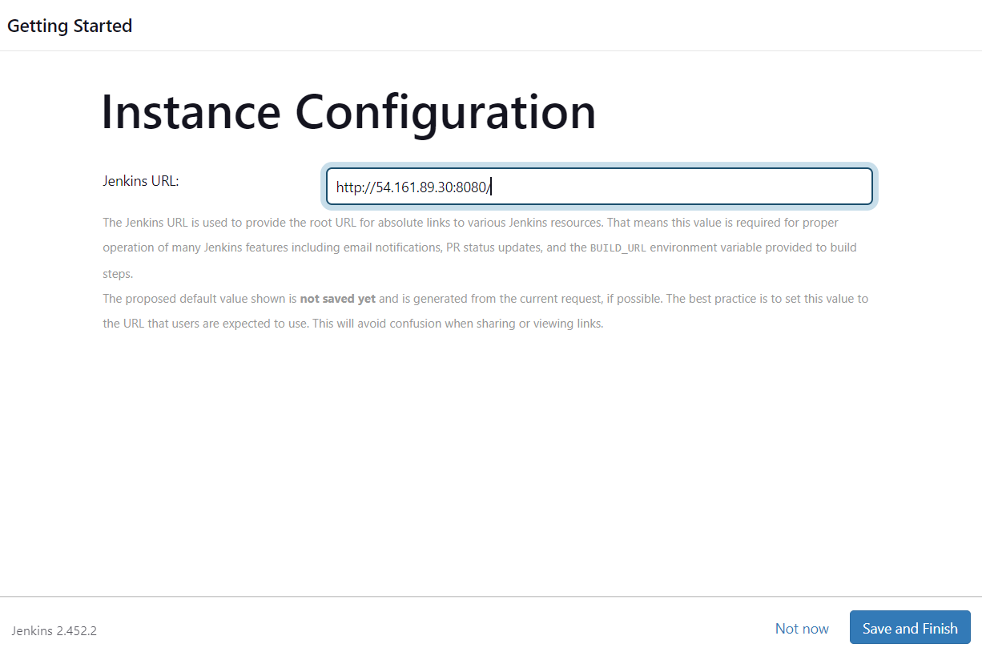

Step 2.4- The default installation has executed

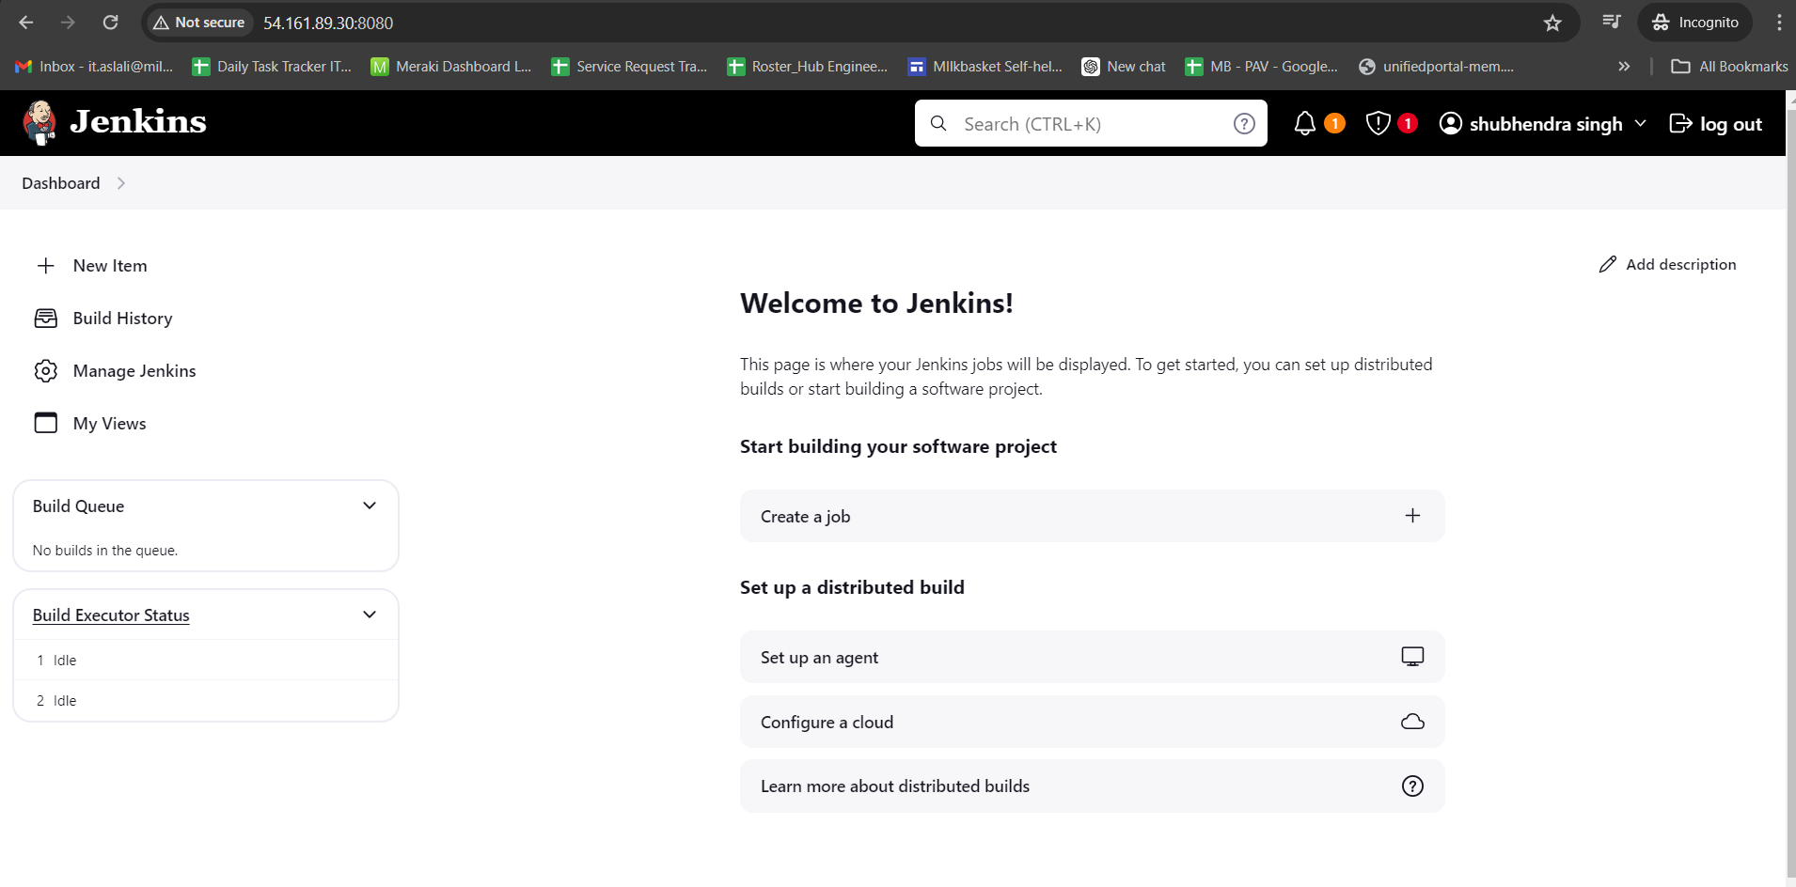
Step 2.5- install docker plugin to perform our solution, because of this is necessary to
click on Manage Jenkins > Manage Plugins

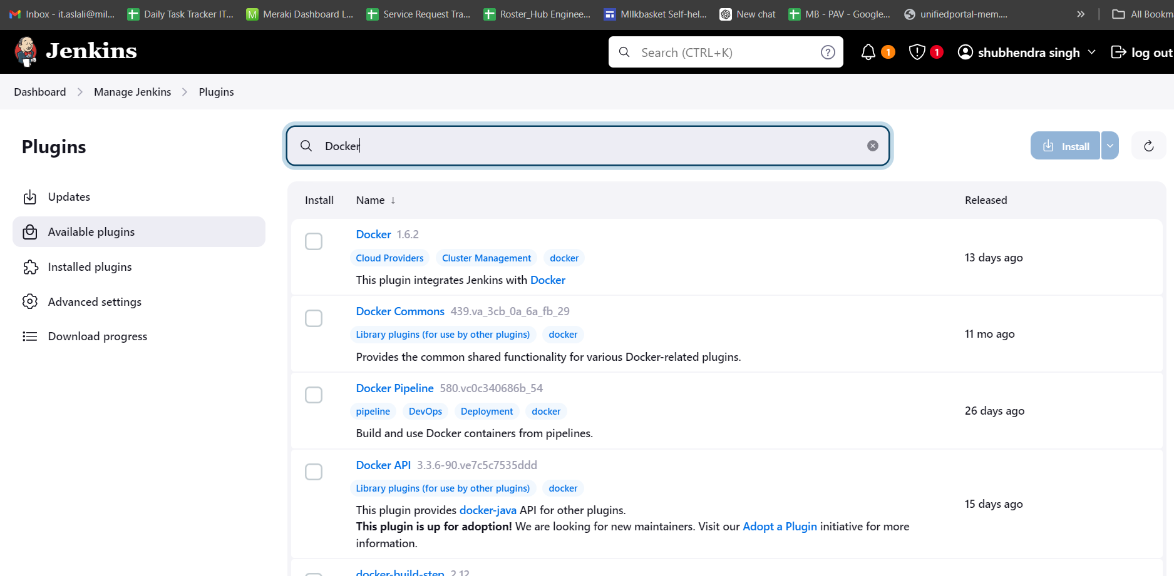
Step 3- Installation Docker

- Step – Docker Installation use below commond
- sudo apt update -y
- sudo apt-get install ca-certificates curl
- sudo install -m 0755 -d /etc/apt/keyrings
- sudo curl -fsSL https://download.docker.com/linux/ubuntu/gpg -o /etc/apt/keyrings/docker.asc
- sudo chmod a+r /etc/apt/keyrings/docker.asc
- echo "deb [arch=$(dpkg --print-architecture) signed-by=/etc/apt/keyrings/docker.asc] https://download.docker.com/linux/ubuntu \ $(. /etc/os-release && echo "$VERSION_CODENAME") stable" | sudo tee /etc/apt/sources.list.d/docker.list > /dev/null
- sudo apt-get update
- sudo apt-get install docker-ce docker-ce-cli containerd.io docker-buildx-plugin docker-compose-plugin

. sudo apt-get update
. sudo apt-get install \ ca-certificates \ curl \ gnupg \ lsb-release

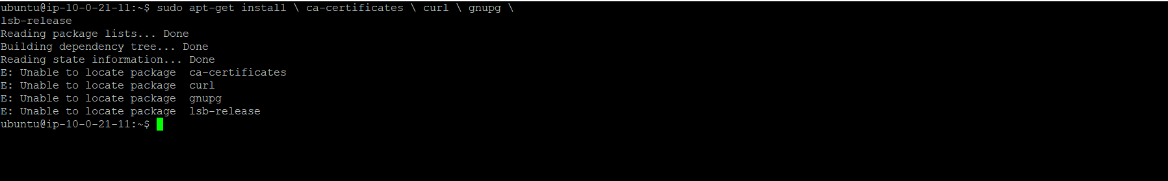

2- sudo install -m 0755 -d /etc/apt/keyrings
3- sudo curl -fsSL https://download.docker.com/linux/ubuntu/gpg -o /etc/apt/keyrings/docker.asc

- sudo curl -fsSL https://download.docker.com/linux/ubuntu/gpg -o /etc/apt/keyrings/docker.asc
- sudo chmod a+r /etc/apt/keyrings/docker.asc
- echo "deb [arch=$(dpkg --print-architecture) signed-by=/etc/apt/keyrings/docker.asc] https://download.docker.com/linux/ubuntu \ $(. /etc/os-release && echo "$VERSION_CODENAME") stable" | sudo tee /etc/apt/sources.list.d/docker.list > /dev/null

sudo apt-get install docker-ce docker-ce-cli containerd.io docker-buildx-plugin

Step 4- GitHub Repository
Create a new Jenkins repository on GitHub WebSite

Step 5- Execute these following commands

echo "# jenkinsdocker" >> README.md
git init
git add README.md
git commit -m "first commit"
git branch -M main
git remote add origin git@github.com:lipelandim/jenkinsdocker.git
git push -u origin main

The github repo is working

Step 6- GitHub webhook
To configure the integration with GitHub.
Create a webhook inside the fork you created:
• Select Settings, then select Webhooks on the left-hand side.
• Choose Add webhook, then enter Jenkins in filter box.
• For the Payload URL, enter http://<publicIps>:8080/github-webhook/. Make
sure you include the trailing /
• For Content type, select application/x-www-form-urlencoded.
• For Which events would you like to trigger this webhook?, select Just the
push event.
• Set Active to checked.
• Click Add webhook.

Step 7- Integrating Jenkins and GitHub
To have Jenkins respond to an event in GitHub such as committing code, create a Jenkins job.
On Jenkins portal click on New Item

On Source Code Management put the Repository URL

Now is necessary to install Docker Plugin
Click on Manage Jenkins
Click on Manage Plugins

Install these plugins

Click on Project

Step 7- Docker Image

Create docker repository on docker hub

Create docker login

Execute the creation of image from file dockerjenkins

